05. MISC

- Given a perfect binary tree, reverse the alternate level nodes of the binary tree.

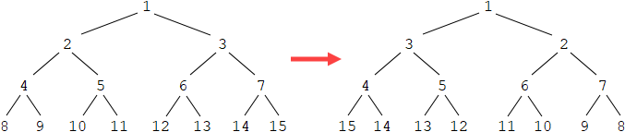

void reverse(Node *a, Node *b, int level)
{
if (a == NULL || b == NULL)
{
return;
}

if (level % 2 == 1)
{
swap(a->data, b->data);
}

reverse(a->left, b->right, level + 1);
reverse(a->right, b->left, level + 1);
}

void reverseAlternate(Node *root)
{
if (root == NULL)
{
return;
}

reverse(root->left, root->right, 1);
}

- Given an undirected graph, check if it is tree or not. An undirected graph is tree if it is connected and has no cycle.

bool Graph::isCyclic(int v, bool visited[], int parent)
{
visited[v] = true;

for (auto it = adj[v].begin(); it != adj[v].end(); ++it)
{
if (!visited[*it])
{
if (isCyclic(*it, visited, v))
{
return true;
}
}
else if (*it != parent)
{
return true;
}
}

return false;
}

bool Graph::isTree()
{
bool visited[V];
memset(visited, false, sizeof(visited));

// Check if it has a circle:
if (isCyclic(0, visited, 0))
{
return false;
}

// Check if all vertices are connected
for (int i = 0; i < V; ++i)
{
if (!visited[i])
{
return false;
}
}

return true;
}

int main()
{
Graph g(5);
g.addEdge(1, 0);
g.addEdge(0, 2);
g.addEdge(0, 3);
g.addEdge(3, 4);

cout << (g.isTree() ? "YES" : "NO");
}

- Given a binary tree, count the number of subtrees in which all the nodes have same value.

bool countUtil(Node *root, int &count)
{
if (root == NULL)
{
return true;
}

bool lc = countUtil(root->left, count);
bool rc = countUtil(root->right, count);

if (lc && rc && (root->left == NULL || root->data == root->left->data)
&& (root->right == NULL || root->data == root->right->data))
{
++count;
return true;
}

return false;
}

int countSubtrees(Node* root)
{
int count = 0;
countUtil(root, count);
return count;
}

- Given a binary tree, find all duplicate subtrees. For each duplicate subtree, return the root node of any one of them. Two trees are duplicate if they have the same structure with same node values.

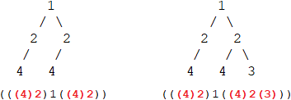

string inorder(Node* root, unordered_map<string, int> &m)
{
if (root == NULL)
{
return "";
}

string str = "(";
str += inorder(root->left, m);
str += to_string(root->data);
str += inorder(root->right, m);
str += ")";

if (m[str] == 1)
{
cout << root->data << endl;
}

m[str]++;
return str;
}

void printDups(Node* root)
{
unordered_map<string, int> m;
inorder(root, m);
}

- Given a binary tree, find the largest subtree having identical left and right subtree.

pair<string, int> findUtil(Node *root, int &maxSize, Node *&maxNode) // <hash, size>
{
if (root == NULL)
{
return {"", 0};
}

pair<string, int> lc = findUtil(root->left, maxSize, maxNode);
pair<string, int> rc = findUtil(root->right, maxSize, maxNode);

int size = lc.second + rc.second + 1;
if (lc.first == rc.first && size > maxSize)
{
maxSize = size;
maxNode = root;
}

string str = "(" + lc.first + to_string(root->data) + rc.first + ")";
return {str, size};
}

Node *find(Node* root)
{
int maxSize = 0;
Node *maxNode = NULL;

findUtil(root, maxSize, maxNode);
return maxNode;
}

- Given a binary tree, check whether it contains a duplicate subtree of size 2 or more.

bool checkUtil(Node *root, unordered_set<string> s)
{
if (root == NULL)
{
return false;
}

if (root->left == NULL && root->right == NULL)
{
return false;
}

if (root->left != NULL)
{
string str = root->data + "+" + root->left->data;
if (s.find(str) != s.end())
{
return true;
}
s.insert(str);
}

if (root->right != NULL)
{
string str = root->data + "+" + root->right->data;
if (s.find(str) != s.end())
{
return true;
}
s.insert(str);
}

return checkUtil(root->left, s) || checkUtil(root->right, s);
}

bool check(Node *root)
{
unordered_set<string> s;
return checkUtil(root, s);
}

- Given a binary tree, find the maximum value in all left nodes.

int findMax(Node* root)
{
if (root == NULL)
{
return INT_MIN;
}

int lc = findMax(root->left);
int rc = findMax(root->right);
int m = max(lc, rc);

if (root->left != NULL)
{
m = max(m, root->left->data);
}

return m;
}

The following shows another solution.

int findMax(Node *root, bool isleft = false)
{
if (root == NULL)
{
return INT_MIN;
}

int lc = findMax(root->left, true);
int rc = findMax(root->right, false);
int m = max(lc, rc);

if (isleft)
{
m = max(m, root->data);
}

return m;
}

- Given a binary tree, find the sum of all nodes which have a child node with value k. The following returns 11 given k = 2.

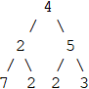

int getSum(Node* root, int k)
{
if (root == NULL)
{
return 0;
}

int lc = getSum(root->left, k);
int rc = getSum(root->right, k);

if (root->left != NULL && root->left->data == k ||
root->right != NULL && root->right->data == k)
{
return lc + rc + root->data;
}

return lc + rc;
}

- Given a binary tree, find the difference between the sum of nodes at odd level and the sum of nodes at even level.

int diff(Node* root)
{
if (root == NULL)
{
return 0;
}

int lc = diff(root->left);
int rc = diff(root->right);

return root->data - lc - rc;
}

- Given a binary tree with positive integer values, find the maximum sum of nodes such that the nodes are picked up from non-adjacent levels.

int getSum(Node* root);

int getSumInclude(Node* root) // return the maximum sum including the root node
{
if (root == NULL)
{
return 0;
}

int sum = root->data;
if (root->left != NULL)
{
sum += getSum(root->left->left);
sum += getSum(root->left->right);
}

if (root->right != NULL)
{
sum += getSum(root->right->left);
sum += getSum(root->right->right);
}

return sum;
}

int getSum(Node* root)
{
if (root == NULL)
{
return 0;
}

return max(getSumInclude(root), getSumInclude(root->left) + getSumInclude(root->right));
}

The following shows another solution. You can use array too if you find the levels first.

void getLevelSums(Node *root, map<int, int> &m, int level)
{
if (root == NULL)
{
return;
}

m[level] += root->data;

getLevelSums(root->left, m, level + 1);
getLevelSums(root->right, m, level + 1);
}

int getSum(Node* root)
{
map<int, int> m;
getLevelSums(root, m, 1);

int inCurr = 0;
int exCurr = 0;

for (auto it = m.begin(); it != m.end(); ++it)
{
int temp = exCurr;
exCurr = max(exCurr, inCurr);
inCurr = temp + it->second;
}

return max(inCurr, exCurr);;
}

- Given a binary tree with integer values, find the maximum sum of nodes such that NO two nodes are adjacent.

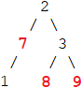

pair<int, int> getSum(Node *root)
{
if (root == NULL)
{
return {0, 0};
}

pair<int, int> lc = getSum(root->left);
pair<int, int> rc = getSum(root->right);

int inCurr = root->data + lc.second + rc.second;
int exCurr = max(lc.first, lc.second) + max(rc.first, rc.second);

return { inCurr, exCurr };
}

int getMaxSum(Node* root)
{
pair<int, int> p = getSum(root);
return max(p.first, p.second);
}

The following shows another solution.

int getSum(Node *root)
{
if (root == NULL)
{
return 0;
}

int include = root->data;
if (root->left != NULL)
{
include += getSum(root->left->left);
include += getSum(root->left->right);
}

if (root->right != NULL)
{
include += getSum(root->right->left);
include += getSum(root->right->right);
}

int exclude = getSum(root->left) + getSum(root->right);
return max(include, exclude);
}

- Given a binary tree, extract all leaves in a Doubly Linked List. In the DLL, the left pointer points to the previous node and the right pointer points to the next node.

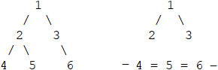

Node *extract(Node *root, Node **head)
{
if (root == NULL)
{
return NULL;
}

if (root->left == NULL && root->right == NULL)
{
root->right = *head;

if (*head != NULL)
{
(*head)->left = root;
}

*head = root;
return NULL; // extract the leaf node
}

root->right = extract(root->right, head);
root->left = extract(root->left, head);

return root;
}

- Given n pairs, each pair represents the value of a node and the sum of its children nodes, find the root node. For example, given {15, 0}, {8, 0}, {5, 0}, {20, 23}, {10, 5}, {36, 30}, the root is 36.

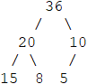

Every node appears once in the first part of the pairs, and every node except for the root appears once in a sum.

int findRoot(pair<int, int> a[], int n)
{
int sum1 = 0;
int sum2 = 0;

for (int i = 0; i < n; ++i)
{
sum1 += a[i].first;
sum2 += a[i].second;
}

return sum1 - sum2;
}

- Given an array that represents Inorder traversal, find all possible binary trees and print their Preorder traversals. For example, given {4, 5, 7}, the preorder traversals of different possible binary trees are:

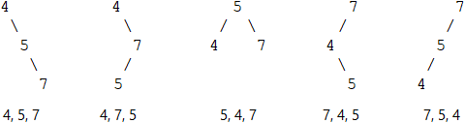

void preorder(Node *root)
{
if (root != NULL)
{
printf("%d ", root->data);

preorder(root->left);
preorder(root->right);
}
}

vector<Node*> getTrees(int a[], int start, int end)
{
vector<Node*> vec;

if (start > end)
{
vec.push_back(NULL);
return vec;
}

for (int i = start; i <= end; ++i)
{
vector<Node*> ltrees = getTrees(a, start, i-1);
vector<Node*> rtrees = getTrees(a, i+1, end);

for (int j = 0; j < ltrees.size(); ++j)
{
for (int k = 0; k < rtrees.size(); ++k)
{
Node * root = new Node(a[i]);
root->left = ltrees[j];
root->right = rtrees[k];
vec.push_back(root);
}
}
}

return vec;
}

int main()
{
int a[] = {4, 5, 7};
int n = sizeof(a) / sizeof(a[0]);

vector<Node*> trees = getTrees(a, 0, n-1);

for (int i = 0; i < trees.size(); ++i)
{
preorder(trees[i]);
printf("\n");
}
}

- Given a number n, count the number of binary trees whose Preorder sequence has a length of n.

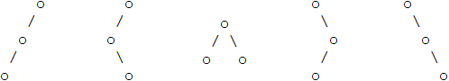

int countTrees(int n)
{
if (n == 0 || n == 1)
{
return 1;
}

int sum = 0;
for (int i = 1; i <= n; ++i)
{
sum += countTrees(i - 1) * countTrees(n - i); // left * right
}

return sum;
}

- Given an array of integers which are greater than 1, find the number of full binary trees that can be constructed from the given integers. In each tree, any non-leaf node is the product of its two children nodes. Each integer can be used multiple times in a full binary tree. For example, given {2, 3, 4, 6}, returns 7.

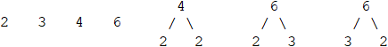

int find(int a[], int n)
{
sort(a, a + n);

unordered_map<int, int> m;
int count = 0;

for (int i = 0; i < n; ++i)
{
m[a[i]] = 1;
++count;
}

for (int i = 1; i < n; ++i)
{
for (int j = 0; j < i; ++j)
{
if (a[i] % a[j] == 0)
{
int k = a[i] / a[j];

if (m.find(k) != m.end())
{
int mul = m[a[j]] * m[k];
count += mul;

m[a[i]] += mul;
}
}
}
}

return count;
}

